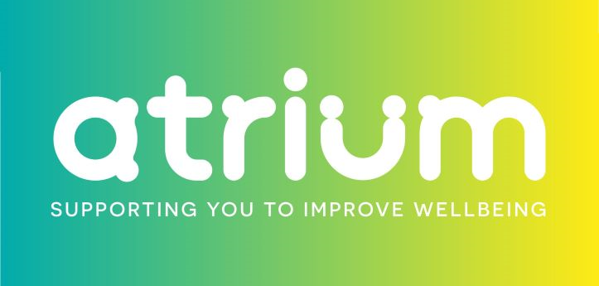

What is Modern Slavery and Human trafficking?

- Modern Slavery takes many forms but includes recruiting, harbouring, transporting, providing, or obtaining a person for compelled labour through the use of force, fraud, or coercion.

Atrium Clinic policy on modern slavery and Human Trafficking

- We are committed to acting ethically, implementing and enforcing effective systems and controls to ensure modern slavery is not taking place anywhere in our business or in any of our supply or sub-contractor chains.
- We are committed to ensuring there is transparency in our practices and supply chains consistent with our disclosure obligations under the Modern Slavery Act 2015.
- We are committed to continually raising our standards and practices in assessing and monitoring those that work with us and those who work for us and monitoring our hosted sites of service delivery. We expect the same high standards from all our staff, contractors, suppliers and business partners in any capacity.

Self employees, employee and sub-contractor partner Obligations

- The prevention, detection and reporting of modern slavery in any part of our business or supply chains is the responsibility of all those working for us. You are required to avoid any activity that might lead to, or suggest, a breach of this responsibility.
- You must notify your Atrium contact as soon as possible if you believe or suspect that a conflict with this responsibility has occurred, or may occur in the future.
- You are encouraged to raise concerns about any issue or suspicion of modern slavery in any parts of our business or supply chains immediately.
- If you suspect or are unsure about whether a particular act, the treatment of workers more generally, or their working conditions within any tier of our supply chains constitutes any of the various forms of modern slavery, raise it with your Atrium contact.
- We will support anyone who raises genuine concerns in good faith, even if they turn out to be mistaken.

Partner Commitments –when you work with Atrium you commit to

- Remaining vigilant to the welfare and wellbeing of others.
- Complying with non-negotiable contractual clauses, that:
- ensures compliance with the Modern Slavery Act 2015;
- assures that slavery is not taking place in your business or in any of the supply chain concerned with your services or in the host area that employs Atrium staff;
- assures that you have put all required policies and procedures in place;
- provide for termination of the arrangement for non-compliance either with the Act or with this information.

Risk areas

- All employees involved or engaged with suppliers in the construction, food, hospitality and recruitment sectors are at most risk.
- Those from Eastern European countries such as Lithuania, Poland, Romania, Slovakia and Hungary, who are promised a job in the UK and then forced to work for little or no money.
- Atrium Clinic commits to only use hospitality and catering services that meet our standards in respect of this policy and agrees to undertake reasonable checks and assurances.

Manager and administrative staff responsibilities

- Recruitment and DBS checks – for new starters, we check Right to work and up to date DBS certification/dates
- Collect referees eg.NHS and public bodies
- Accreditation in recognised UK professional bodies eg. HCPC, BACP, NCS, NHS Nursing registrations
- Insurances;

